**Modual-9) REACT-Components,State,Props**

**1. What is React Js?**

**Ans)**

*->React is a open-source front-end JavaScript library for building user interfaces based on components.*

*->It is maintained by Meta and a community of individual developers and companies.*

*->React can be used to develop single-page, mobile, or server-rendered applications with frameworks.*

**2. What is NPM in React Js?**

**Ans)**

*->NPM stands for Node Package Manager.*

*->It is a package manager for JavaScript.*

*->NPM is used to manage and share packages (libraries, tools, and frameworks) for Node.js, which includes packages that are commonly used in front-end development, including React.js.*

**3. What is Role of Node Js in react Js?**

**Ans)**

->*Node.js plays a significant role in React.js development, primarily in the context of building and managing the development environment, as well as facilitating server-side rendering and back-end integration.*

*->Node.js is a crucial part of the React.js development ecosystem, serving as the foundation for development tools, build processes, server-side rendering, and server-side logic.*

*->The combination of React.js on the front end and Node.js on the back end provides a full-stack JavaScript solution for building modern web applications.*

**4. What is CLI command In React Js?**

**Ans)**

->*CLI stands for Command Line Interface.*

*->They are typically used to create, build, test, and deploy React applications from the command line.*

*->The Command Line Interface (CLI) is often used to perform various tasks such as creating a new React application, running a development server, building the application for production, and more.*

*->The most common CLI tool used for React.js development is create-react-app.*

**5. What is Components in React Js?**

**Ans)**

*->Components are the fundamental building blocks of React applications.*

*->Components are independent and reusable bits of code.*

*->Components come in two types, Class components and Function components.*

**6. What is Header and Content Components in React Js?**

**Ans)**

->*The Header component typically represents the top section of a web page or application.*

*->It often contains elements like the site logo, navigation menu, user authentication status, and other header-related information*.

Code=>

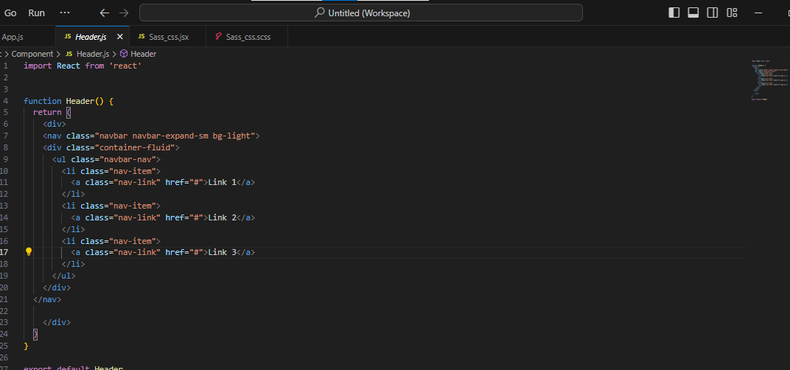

**Content Component:**

->The Content component typically represents the main section of a web page or application where the primary content is displayed.

->It can vary significantly depending on the specific page or view within the application. The content section is dynamic and changes based on user interactions or navigation.

Code=>

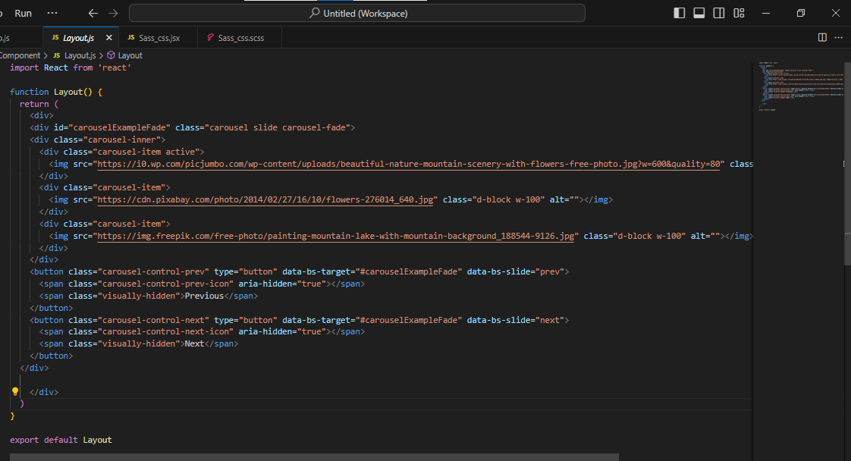

**7. How to install React Js on Windows, linux Operating System?**

**Ans)**

*Step-1: Visit the Node.js download page at:* [*https://nodejs.org/en/download/*](https://nodejs.org/en/download/) *.*

*Step-2: Download the installer for your Windows system.*

*Step-3: To install Node.js and npm, please run the installer and carefully follow the provided prompts.*

*Step-4: Install Create React App. Create React App is a command-line tool that simplifies the process of setting up a new React project with a recommended project structure and configuration. To install Create React App globally, open a command prompt and run the following command:*

***npm install -g create-react-app***

*->Then after make create react app code in terminal of command prompt.*

***Create-react-app my-task***

**8. How to install NPM and How to check version of NPM?**

**Ans)**

*->After node.js download and installation after that create folder in any drive*

*->Just like name React. Then after open the cmd for these particular path and paste the code:*

**npm install**

->For version check command : **npm –v**

**9. How to check version of React Js?**

**Ans)**

*Step-1: Open the ‘package.json’ file in the root directory of your React project.*

*Step-2: Look for the ‘ “dependencies” ’ section, where you’ll find the version of ->React installed. It will be listed as ‘ “react”: “x.x.x” ’. The numbers ‘x.x.x’ represent the version*

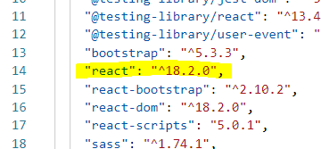

10. How to change in components of React Js?

Ans)

*There are several ways to change components in React JS:*

*1. Updating State:*

*->If the change involves updating the component’s internal data, use the* ***useState*** *hook to manage the state and trigger a re-render when the state changes.*

*->Update the state using the* ***setState*** *function within event handlers or other logic that modifies the data.*

*->The component will re-render with the updated state, reflecting the changes in the UI.*

1. *Passing Props:*

*->If the change involves modifying the component based on external data, pass the data as props from the parent component.*

*->Update the props in the parent component when the data changes.*

*->The child component will receive the updated props and re-render with the new information, reflecting the change in the UI.*

1. *Conditional Rendering:*

*->Use conditional statements like* ***if*** *or ternary expressions (****? :****) to selectively render different content based on props or state.*

*->This allows you to dynamically show or hide parts of the component based on specific conditions.*

**11. How to Create a List View in React Js?**

**Ans)**

**Code=>**

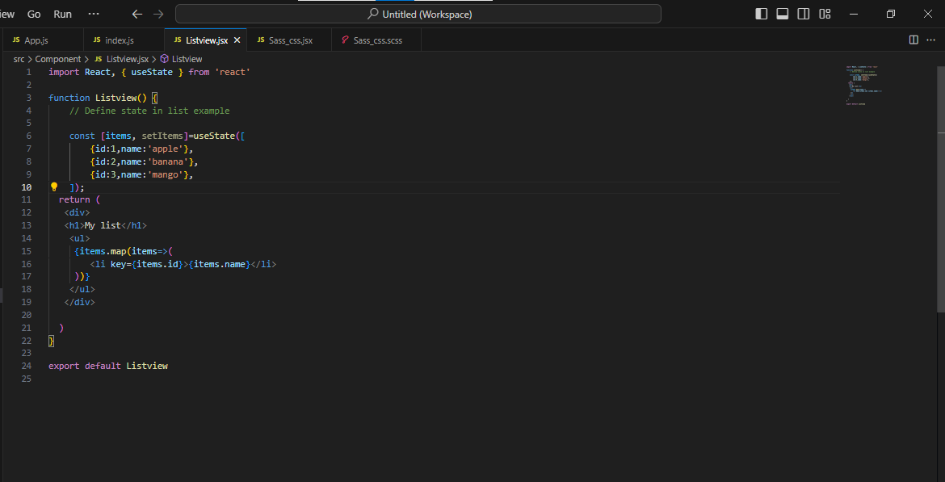

**Output=>**

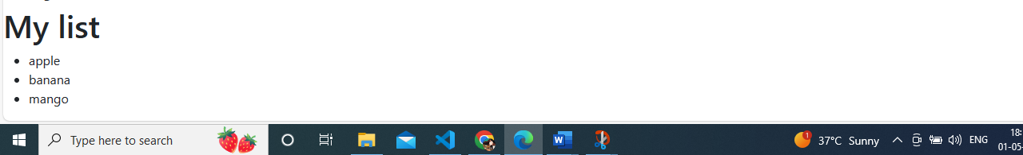

**12. Create Increment decrement state change by button click?**

**Ans)**

**Code=>**

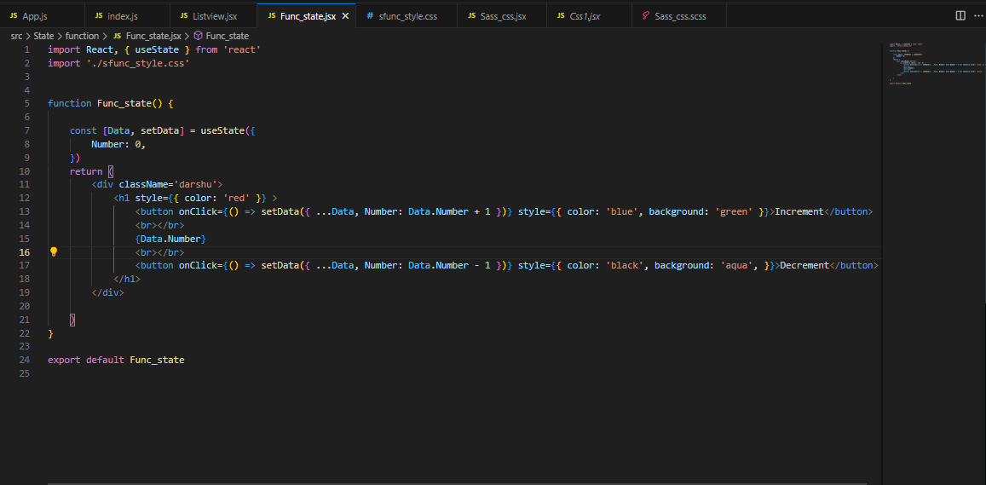

**Output:**

